Title:  Artist:  Medium:  Project:  Teacher: Grade:  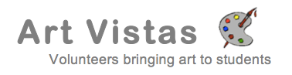 | Title:  Artist:  Medium:  Project:  Teacher: Grade:
Title:  Artist:  Medium:  Project:  Teacher: Grade: | Title:  Artist:  Medium:  Project:  Teacher: Grade:
Title:  Artist:  Medium:  Project:  Teacher: Grade: | Title:  Artist:  Medium:  Project:  Teacher: Grade:
Title:  Artist:  Medium:  Project:  Teacher: Grade: | Title:  Artist:  Medium:  Project:  Teacher: Grade:
Title:  Artist:  Medium:  Project:  Teacher: Grade: | Title:  Artist:  Medium:  Project:  Teacher: Grade:

